REQUEST FOR PROPOSAL (“RFP”)
FOR 4WD PICKUP VEHICLE FOR ALLO TECHNOLOGY SDN. BHD.
………………………………..

- INTRODUCTION

  - Background

    - ALLO is TNB Subsidiary which is a telecommunication company that has scattered Network Elements (NEs) at Central, Northern, and Southern Region.
    - With that, ALLO is inviting qualified and interested Vendor to submit its Proposal for 4WD pickup vehicle.
    - There are several sites covered by ALLO which need to be on standby and need Vendor to quote 4WD pickup vehicle with the budgetary cost to ALLO and to provide other documents as required.
No | Region | State
 | Central | Selangor, Putrajaya, KL
 | Northern | Perak, Kedah
 | Southern | Negeri Sembilan, Melaka, Johor

  - General Criteria to Participate in the RFP

    - Vendor must fulfil the following mandatory requirements in order to submit the Proposal:
- A company incorporated in Malaysia and registered with Tenaga Nasional Berhad and/or Allo Technology Sdn Bhd
- No litigation issues
- A company with sound financial standing
- A company to sign Allo Integrity Pact.

    - Each Proposal received will be reviewed and the information required is not limited to the following:
- Comply with all conditions and requirements stated in this RFP
- Provide a bill of quantity of above elements
- Provide a budgetary cost per 4WD pickup vehicle
    - ALLO reserves the right not to disclose the evaluation method.
    - ALLO reserves at its absolute discretion, the right to accept or reject any of the Proposals without giving any reasons thereto and ALLO is under no obligation whatsoever to reimburse any expenses incurred by Vendor in the preparation and submission of the Proposal.
    - All decisions made in relation to this RFP are final and no appeal will be entertained.
    - Proposal together with the required and relevant completed documents (including Forms as per the Attachment A,) must be submitted in one (1) set. The Proposal shall be enclosed in a sealed envelope and marked with RFP’s title as below:
Allo Technology Sdn Bhd.
(Attn: Head of Procurement & Supply Chain)

Title: REQUEST FOR PROPOSAL (“RFP”)
FOR 4WD PICKUP VEHICLE FOR ALLO TECHNOLOGY SDN. BHD.

CLOSING DATE: 24th July 2024

    - The Proposal document shall be delivered physically into tender box not later than 12:00 noon, 24th July 2024 (Thursday) to the address as indicated below:
Tender Box
ALLO TECHNOLOGY SDN BHD
Procurement & Supply Chain Department,
Level 3, Left Wing,
NOVA Building, UNITEN,
43000 Kajang, Selangor.

ALLO will not be responsible for any missing or undelivered document. A vendor’s proof of posting and/or submitting by some other means will not be accepted as proof of receipt by ALLO.

  - Definition

The following words and expressions shall have the meanings stated below, unless otherwise specified.
Proposal The aggregate of all documents submitted to ALLO by Vendor in response to the RFP.
Vendor Parties who submit the Proposal.
Project Request for Proposal (RFP) for 4WD Pickup Vehicle for Allo Technology Sdn Bhd.

- GENERAL INFORMATION OF THE FOR THE 4WD PURCHASE PROPOSAL

The vehicle requirements are illustrated as per diagram below.

  - ALLO 4WD pickup vehicles:

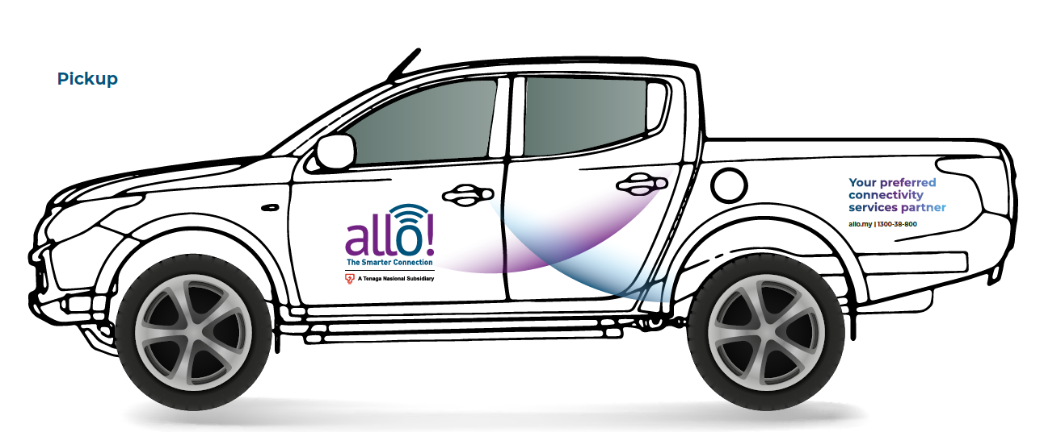

diagram 1

  - Accessories: Roof rack, Canopy, Rear LED Directional Light and LED Blinkers (amber)

  - Payload: Up to 1000kg

- INFORMATION / DOCUMENTS REQUIRED TO BE INCLUDED IN THE PROPOSAL

The document to be provided must follow the Table of Content provided whereby a separator must be enclosed for each section stated.

  - Technical Proposal
    - General Requirements (4x4 Pickup Vehicle) – 6 Units

• Year manufactured- Not earlier than 2022 (must be unused)
• Model: Any
• Fuel: Diesel
• CC: Minimum 2000
• Colour: White
• Transmission type: Auto
• Fuel tank volume (liters): Vendor to specify
• Tyre Tye: AT
• Accessories: Canopy, Rear LED Directional Light & LED Blinkers (Amber), Spare Tyre, Tyre Repair Kits Accessories, Sidestep, Tinting as JPJ regulation and Dash Cam
• Cab Type: Double
• Warranty (years or number of kms): Vendor to specify
• Maintenance package: Vendor to Specify
• Lead Time Delivery after purchase: Vendor to specify

  - Commercial Proposal
- Budgetary cost per vehicle
- Inclusive sticker / printed as per diagram 1
- Value added services (if any)

  - Any other related documents and information that Vendor wishes to include in support of its Proposal.

- FORM SUBMISSION REQUIREMENT

  - Vendor is compulsory to fill up the forms as per the Attachment A. Extend the space in the form if required.

  - For any irrelevant matters, shall be filled with “Not Applicable”.

  - All information requested for the Proposal shall be furnished in English language or Bahasa Malaysia.

- GENERAL TERMS & CONDITIONS

  - ALLO’s Right

    - ALLO reserves the right to:
- reject or accept any Proposal; and/or
- cancel the RFP process and reject all Proposals

ALLO shall neither be liable for any such actions nor be under any obligation to inform Vendor of the grounds for them.
    - ALLO is not liable for any costs incurred by Vendor in preparing and submitting the Proposal, nor will it be liable for any costs incurred by Vendor in preparing further information.
    - ALLO shall be entitled, at its sole and absolute discretion without assigning any reason therefore, to not award to any Vendor any contract for the Project pursuant to any Proposal submitted under this RFP. It shall be agreed and understood that in such event, there shall be no course of action against ALLO, nor shall it be possible to pursue a course of action against ALLO for any such action howsoever arising and ALLO shall not be liable for any cost, loss of profit and/or expenditure howsoever arising on Vendor’s part.
    - Whilst care is taken to ensure that the facts and information contained in this RFP are correct at the time is presented, ALLO hereby makes no representation as to the accuracy and adequacy of such facts and information contained in the RFP. ALLO shall not be liable for any inaccuracy or inadequacy of such facts and information.

  - Miscellaneous

    - If any information in the Proposal is found to be misrepresented or concealed, the Proposal will be rejected.

- Particulars of Vendor

  - Company General Information

Name of Company
Bil | Item | Description
1 | Date of Incorporation
2 | Company Registered Address | Tel No.:  Fax No.:
3 | Nature of Business | 1.
3 | Nature of Business | 2.
3 | Nature of Business | 3.
4 | Company Registration  (Tenderer shall clearly state the company registration and provide the relevant supporting documents) | Registration | Registration No. | Required Documents
4 |  | Suruhanjaya Syarikat Malaysia (SSM)* |  | Latest E-Info SSM Report with digitally certified true copy
4 |  | A company incorporated in  Malaysia and registered with Tenaga  Nasional Berhad (“TNB”) and/or Allo Technology Sdn Bbhd | TNB Registration No:  Vendor to Allo Technology  (Yes/No) | Vendor registration  Certificate
5 | Key Personnel | Designation |  |  | Staff Name
5 | Key Personnel | Managing Director/Chief Executive Officer
6 | Contact Person | Name:
6 | Contact Person | Designation:
6 | Contact Person | Tel No.:
6 | Contact Person | Email:

Note: Required to provide the relevant supporting documents

13. Vendor’s Information
Vendor who has yet register with ALLO, is required to provide the relevant supporting documents as below:
Bil | Document | Please tick (✓)
1 | Company’s general information /Company profile
2 | SSM e-info’s Company Profile (Digital Certified True Copy)
3 | SSM e-info’s Attestation of Company Good Standing

- Litigation Declaration Form (Affidavit)

I, “Your Name” (NRIC No.: ……………………….), being a director of …………………. (Company No.), a company incorporated in Malaysia with its registered office at “Company’s address” do hereby affirm this statutory declaration on behalf of ………….…………

- I am the Director of ……………. ….. (Company No.) and am duly authorized to make this affidavit on its behalf.

- The matters deposed to herein are within my own personal knowledge.

- I state that as at the date of this affidavit our company has no litigation case(s) to Tenaga Nasional Berhad and its subsidiary, Allo Technology Sdn. Bhd.

And I make this solemn declaration believing the same to be true and by virtue of the provision of Statutory Declarations Act 1960.

Subscribed and solemnly declared )
By the above named )
“Your Name” )
(NRIC NO.: ) ……………………………………………………………………………….
at ………………. )
this )
Before me,

…………………………………….
Commissioner for Oaths

*This form must be print using company’s letterhead

Commercial Proposal

  - Budgetary cost per 4WD vehicle (6 Units in total):
Vendor to provide details of breakdown.

Scope | Description |  | Price (per unit)
Regulatory & Compliance | 4WD Vehicle Model:
Regulatory & Compliance | Year manufactured- Not earlier than 2022 (must be unused)
Regulatory & Compliance | Fuel: | Diesel
Regulatory & Compliance | CC (Minimum 2000):
Regulatory & Compliance | Colour: | White
Regulatory & Compliance | Transmission type: | Auto
Regulatory & Compliance | Fuel tank volume (liters):
Regulatory & Compliance | Tyre Type: | Tyre
Regulatory & Compliance | Accessories: | Canopy, Rear LED Directional Light & LED Blinkers (Amber), Spare Tyre, Tyre Repair Kits Accessories, Sidestep, Tinting as JPJ regulation, Dash Cam
Regulatory & Compliance | Warranty (years or number of kms):
Regulatory & Compliance | Maintenance package:
Regulatory & Compliance | Lead Time Delivery after purchase:
Regulatory & Compliance | Cab | Double
Regulatory & Compliance | Design Sticker/Printed | As per Diagram 1

  - Value Added Services

Value Added Services (for the benefit of ALLO or others, if applicable)
1
2
3
4

